Key Stage 1  English Learning Journey  Outcome:  Purpose: To entertain  Audience: Younger Children  Form: Own version of a short narrative story | Text:  Oral retelling of fairy tales and traditional tales from around the world  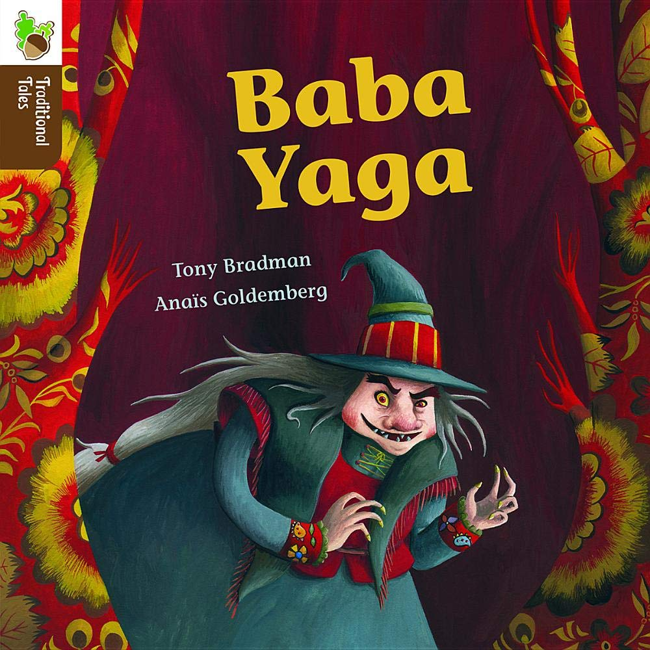  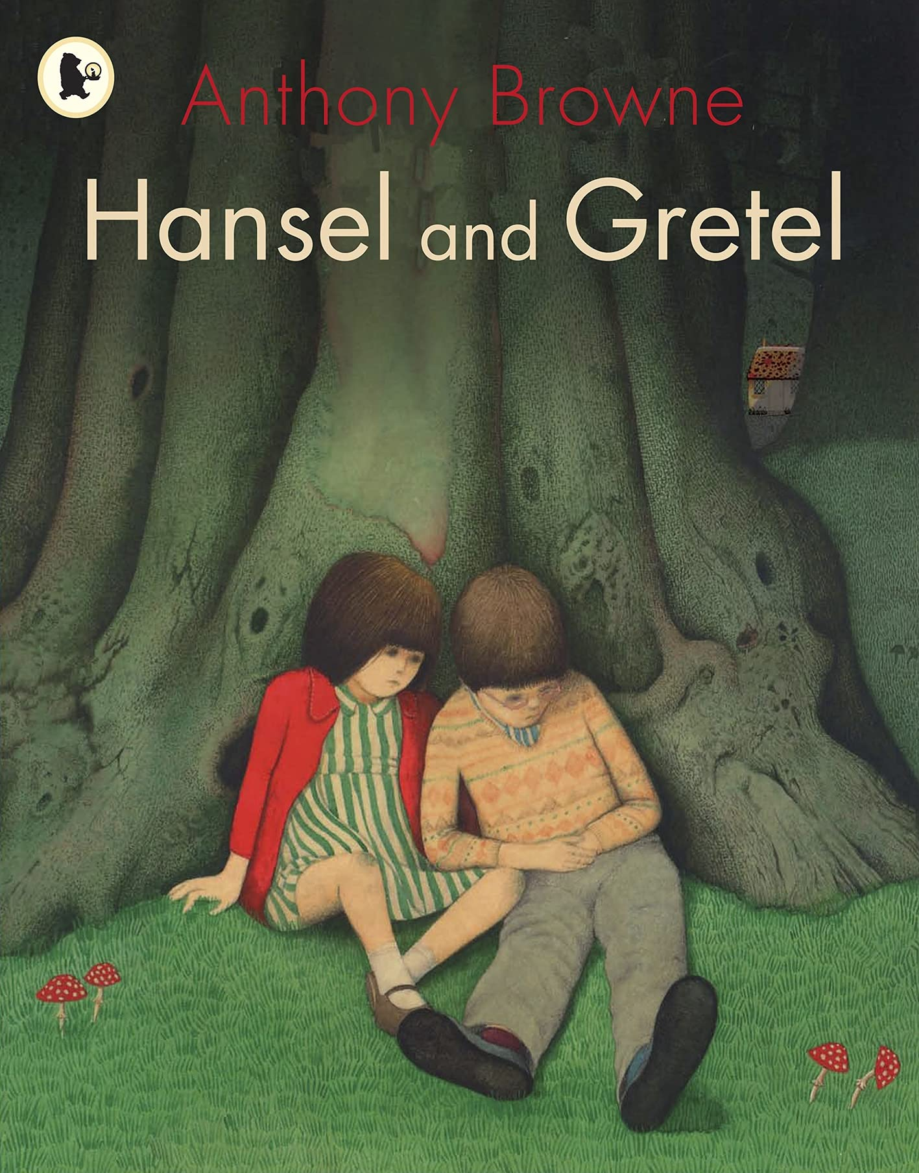  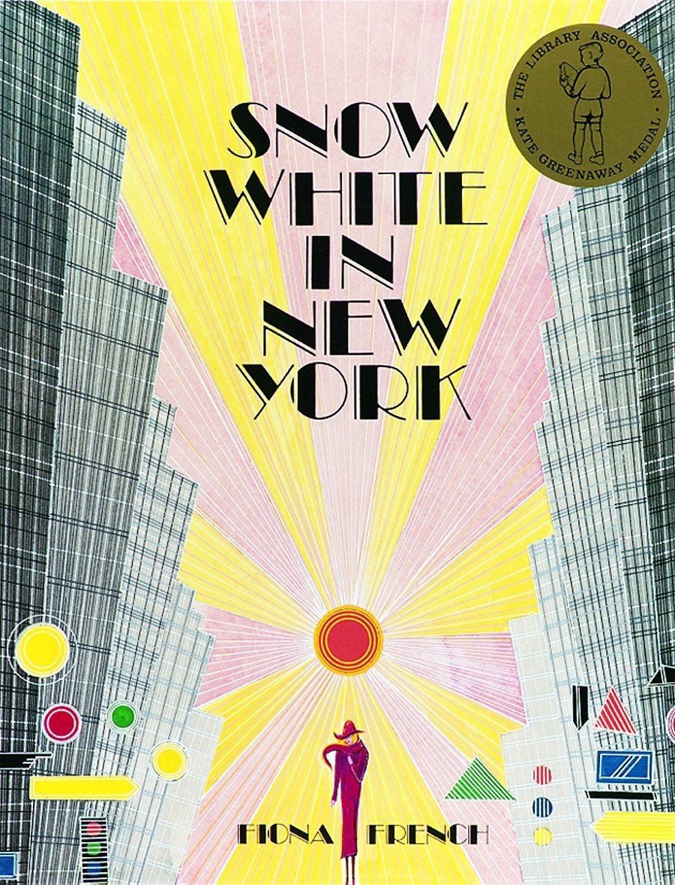 | Key Writing Statements  Year 1  -to have a clear beginning, middle, end, signalled by familiar language e.g once upon a time  -to attempt writing in the third person  -to be written in the appropriate tense, consistently  -to write simple sentences  -to use simple conjunctions (and, then, but, so)  -to use adjectives  Year 2  -to organise sentences chronologically  -to use time connectives  - to use paragraphs  -to use speech like expressions  -to use story language  Key Reading Statements  Year 1  -Give/explain the meaning of words in context.  -Retrieve and record information/identifying key details from fiction and non-fiction.  -Summarise main ideas from more than one paragraph  -Make inferences from the text/ explain and justify inferences with evidence from the text.  -Predict what might happen on the basis of what has been said and done  Year 2  -Give/explain the meaning of words in context.  -Retrieve and record information/identify key details from (fiction) and non fiction  -Summarise main ideas from more than one paragraph.  -Make inferences from the text/explain and justify inferences with evidence from the text.  -Predict what might happen on the basis of what has been said and done.
Linked Guiding Reading Texts
Yr 1 – Fairy Tales/3 Little Pigs

Overview of Learning Journey – Fairy Tales
Stimulate & Generate | Capture, Sift & Sort | Create, Refine, Evaluate
To explore a range of fairy tales and identify patterns  Explain what a fairy tale is. Show a range of fairy tales and read each title. Ask child to vote on a story and read it. Display question prompts and discuss. Record answers/ideas on post it notes. Children work in mixed ability groups – to read and identify the setting, characters, special object and familiar phrases. Record ideas on post it. Discuss and compare ideas.  To sequence a traditional version of Cinderella  Explain that fairy tales has been orally passed along generations. Orally tell the story of Cinderella. Discuss. Orally sequence the story – use hand of 5. Repeat and rehearse oral retelling. Children read and sequence sentences to retell the stories. Discuss and compare each other’s answers.  To investigate characterisation through role play  Orally retell Cinderella. Identify each character. Consider their personality and discuss their role in the story. Explain that children will work in groups to role play the story to explore the feelings and actions of the characters. Freeze frame & photograph. While freeze frame – ask children to consider how their character is feeling and how emotions affect behaviour. Share photos and discuss emotions and facial expressions.  To generate adjectives to describe settings  Show and read traditional version of Snow White. Agree this is a fairy tale. Identify the different settings contained in the story. Discuss other fairy tales and their settings. Write ideas in a vertical list on whiteboard. Select a setting and generate a range of appropriate adjectives to describe it. Year 2 – thesaurus to find alternatives. Orally combine a selection of adjectives and compose a sentence. Model using correct punctuation.  Split children into groups and give each group a setting. Generate adjectives and then use these to compose sentences. Rotate around each group.  To describe a villain using adjectives  Reread/recap Snow White. Identify heroes and villains from the story. Consider other fairy tales and their heroes and villains. Write a vertical list of villains. Display wanted poster. Select a villain and sketch them in the centre – add descriptive labels around the picture.  Children create their own wanted posters – year one expanded noun phrases in sentences, year 2 sentences including more than one expanded noun phrase.  Children read their sentences for other children to guess their villain. | To invent and describe a new fairy tale character  Ask children to name as many fairy tale characters as they can with a partner. Consider if each character is a hero and a villain. Discuss a range of new characters. Select and draw one of them. Orally compose a range of sentences to describe their appearance and personality. Use correct punctuation to write each sentence. Children write about their own new fairy tale character.  To give help and advice to Snow White  Share 3 different versions of Snow White. Identify what is same and different about each. Recognise that Snow White is in danger and why. Discus and share advice on ways to help Snow White. Model composing a letter to Snow White telling her how to stay safe. Children write their own letters. Peer edit.  To share thought and ideas about an oral retelling of Snow White  Show some items from Snow White. Discuss and why these items are significant to the story. Recap story of Snow white. Show discussion questions – in mixed ability groups discuss the questions and answers.  To discuss 2 versions of Snow White  Show front cover of Snow White in New York. Discus and make predictions. Compare to oral retelling of the story. In mixed ability pairs – have set of cards with statements and sort into the two versions. Discuss their thoughts and ideas, justify their ideas with because.  To compose a new version of Snow White  Draw story maps for new versions for Snow White. Use their maps to retell their stories.  To write a punctuated caption to accompany an illustration  Read 3 billy goats gruff. Encourage children to join with repeated refrains. Display pictures and model writing a caption for each picture.  In groups children caption each picture to retell the story.  To write dialogue for characters using a range of punctuation  Recap 3 billy goats gruff, discuss plot and sequence the story. Display pictures – show speech/thought bubbles. Orally explore and prepare a range of different sentences- questions, exclamations and sentences. Model using correct punctuation. Children write their own speech/thought bubbles.  To write a punctuated letter in role  Orally sequence the story of 3 billy goats gruff. Display picture of the troll. Discuss why he might be cross. Pretend to be the goats and write a letter to the troll – model and discuss the use of correct punctuation. Children use templates to write letters to the troll. | To create a new version of The 3 Billy Goats Gruff  Discuss 3 billy goats gruff, read and discuss Billy Dogs Gruff. Identify same/different. Display planning template. Orally discuss and model how to complete. Children complete their own planning templates.  To write their own fairy tale  Display planning template and model using it to write beginning/middle/end. Discuss success criteria.  Children write and edit their own on fairy tales.
Overview of Learning Journey – Traditional Tales
Stimulate & Generate | Capture, Sift & Sort | Create, Refine, Evaluate
To discuss the story  Display in the sky. Discuss. Tell the first part of the story of Baba Yaga & the black geese. Display character outline – ask children for words to describe Olga. Write some around the outline. Make predictions. Read and discuss questions in mixed ability pairs. Children write answers to some/all the questions.  To make story maps for part of a story  Recap first part of the story. Tell the second part of the story and discuss. Children make story maps.  Add to the character outline.  To practise telling the story of Baba Yaga  Recap the story so far. Watch and discuss video of story teller. Model using story maps to retell a story. Children use their own story maps to retell the story.  To make a story map for a whole story  Tell and discus the story of Hansel & Gretel. Recap work on story maps. Children create a story map. | To extend sentences using and, or, but  Read Why Not Me? – in small groups and discuss. Use PowerPoint to recap co-ordinating conjunctions. Give children sentences to extend using conjunctions.  To extend sentences using if, because, that, when  Read and discuss the story of Millie & Victor. Compare to previous stories.  Use PowerPoint to recap subordinating conjunctions. Give children sentences to extend using subordination.  To write a short story using extended sentences  Recap Why not me? & Millie & Victor, discuss how the story might end - model making a story map of ideas, model telling the end of the story. Recap extending sentences using conjunctions. Children write extended sentences to write the end of the story.  To discuss and write about Anthony Brown’s illustrations  Recap Hansel and Gretel story. Show and discuss the blurb of Anthony Brown’s version. Read the first page of the book. Did it start the same way? Discuss and compare. Share illustrations with children in groups and get them to discuss. Show smaller versions pick one and write sentences about their chosen picture.  To imagine Natasha’s thoughts through the story  Return to Baba Yaga story – introduce Baba Yaga by Tony Bradman. Share story & discuss. Show pictures and discuss Natasha’s thoughts. Children write thought bubbles.  To compare 2 books  Recap both stories and show a range of images. Discuss. Children sort comparison cards and complete comparison table.  To group read Hansel and Gretel  Display lots of different versions of Hansel & Gretel. Discuss, and read blurbs. In ability groups children read and discuss an adapted version of Hansel & Gretel using discussion cards.  To write and punctuate different sentences  Show a range of pictures from the stories looked at. Discuss different sentence types. Model creating one of each type for a picture. Discuss different punctuation. Children write their own sentences.  To retell stories using story pegs  Introduce and model using story pegs. Model retelling the story using these instead of the story map.  Children choose a story to make their own story pegs and retell one of the stories. | To plan a story based on a traditional tale structure  Explain we are going to use the story pegs to create our own stories, what can we change? Model telling a new story using story pegs. Model how to complete story planner using oral story just told. Children complete their own story plan.  To draft stories  Model story writing using plans. Go over success criteria before starting.  To finalise stories  Model writing endings. Model self editing. Finish and edit stories.

