South Stoke Primary School
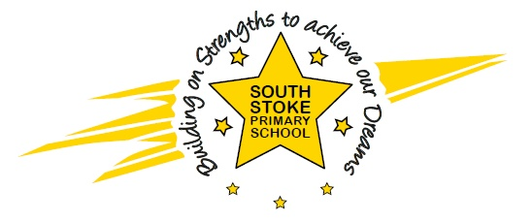
The Street
South Stoke
Nr Reading
RG8 0JS
Telephone / Fax: 01491 872948
Email – office.2507@south-stoke.oxon.sch.uk
www.southstokeschool.org

Headteacher – Miss Amanda Rogers

Stoke Primary School
PHONICS STATEMENT
September 2022

At South Stoke Primary School we are passionate about ensuring all children become confident and enthusiastic readers and writers. We believe that phonics provides the foundations of learning to make the development into fluent reading and writing easier. Through daily, systematic and consistent high quality phonics teaching, children learn to segment words to support their spelling ability and blend sounds to read words. To allow our children to develop a strong phonic awareness and effective blending and decoding skills, we have chosen to use a DfE validated synthetic phonics programme called Twinkl Phonics and their related reading scheme.

We currently use Twinkl Phonics and our early reading books are Twinkl Phonics Rhino Readers; supplemented and supported by texts from Big Cat Phonics, Oxford Reading Tree and Songbirds books where appropriate.

