South Stoke Primary School
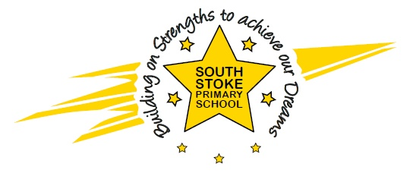
The Street
South Stoke
Nr Reading
RG8 0JS
Telephone / Fax: 01491 872948
Email – office.2507@south-stoke.oxon.sch.uk
www.southstokeschool.org

Headteacher – Miss Amanda Rogers

Safeguarding Statement September 2022

“Safeguarding is everybody’s responsibility”

Children have a right to be cared for and protected, protecting them is everyone’s responsibility. Here at South Stoke Primary School we have a duty of care to ensure that all users of the school are kept safe from harm. We are committed to provide a secure and supportive environment in which children can develop and grow into mature and responsible people.

Safeguarding children is an essential part of our holistic approach to ensure that children are protected from abuse and neglect and that every child reaches their full potential.

The school’s staff, volunteers and service providers have a duty to safeguard and promote the welfare of children as a shared responsibility with parents and other carers. To support this statement, the school may signpost to services that are specialised to promote opportunity, prevent problems, act early and act effectively if and when concerns arise. Therefore, whilst we do not want to worry you, we will report to Children’s Social Care if we have any reason to believe that a child may be at risk of suffering abuse or neglect.

Parents/carers are normally our first point of contact, and if a suspicion of abuse is recorded, parents/carers will be informed at the same time that the record is made; we will support parents/carers and ensure we work in collaboration with them to protect children.

Working with parents/carers to prevent abuse is our primary aim and only when that has failed or in emergency situations will a referral be made to social care. When a referral is made to social care parents will be notified beforehand, except when guidance from social care or the police does not allow this.

We cannot safeguard children alone. All children’s services agencies work in partnership with each other. There are duties and rules about information sharing but if staff, parents or carers have any concerns about a child, other parent, provider, agency or any person, they have a responsibility to report those concerns and we must record and act on them.

At South Stoke Primary School we have safeguarding policies which is underpinned by the Oxfordshire Safeguarding Children Board Procedures and the document “Working Together to Safeguard Children” and Safer Recruitment guidance. The policies apply to all children and young people regardless of gender, ethnicity, disability, sexuality or religion. It is a requirement that all users are informed of these policies and practice guidance and what they should do if they have concerns.

The safeguarding policy is available from the school office or on our website.

If you have any concerns about the practice of our staff team please speak to the Designated Safeguarding Lead (Amanda Rogers) or our Deputy Designated Safeguarding Lead (Nicola Townsend)

What you can do
Parents and carers play a role in safeguarding children in their community. If you have any concerns, no matter how small, you should report them to someone who you trust will listen. The school is required to have a designated safeguarding lead person for this purpose. Parents and children should speak to the safeguarding lead if they have any concerns about a child or staff member.

