English EYFS/Key Stage One
2022 – 2023 |  | Autumn  Chocolate |  |  | Spring  Home & Away  (UK & Italy) |  | Summer  Journeys & Explorers
 |  | Term 1 | Term 2 |  | Term 3 | Term 4 | Term 5 | Term 6
EYFS | Core Text | 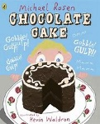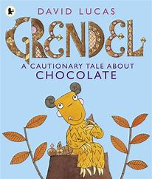 | 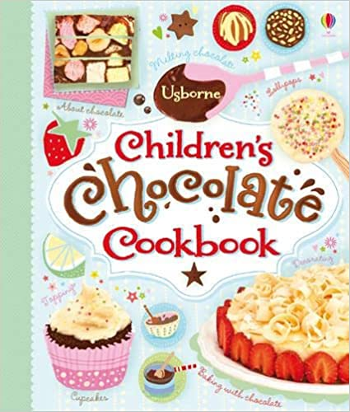  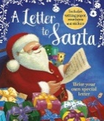 |  | 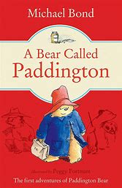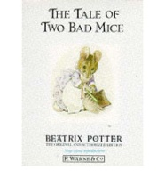 | A range of traditional tales  - Cinderella  - Snow White  - 3 Billy goats Gruff  - Hansel & Gretel  - Baba Yaga | 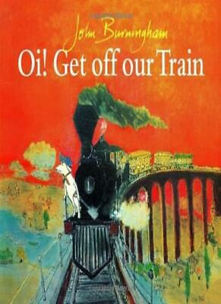  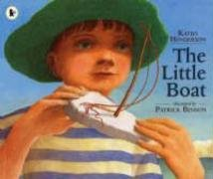  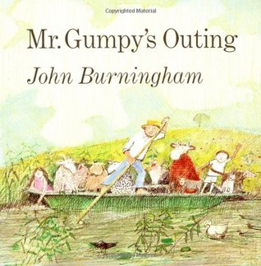  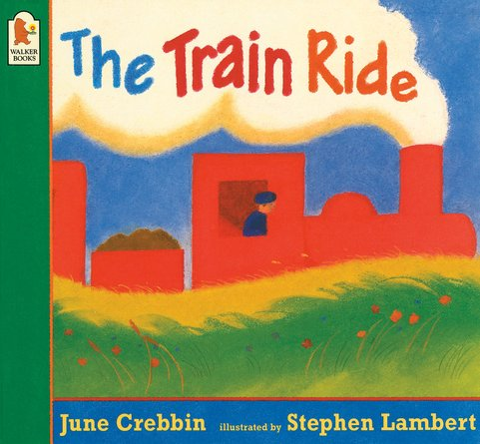 | 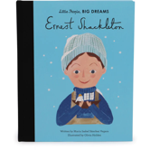  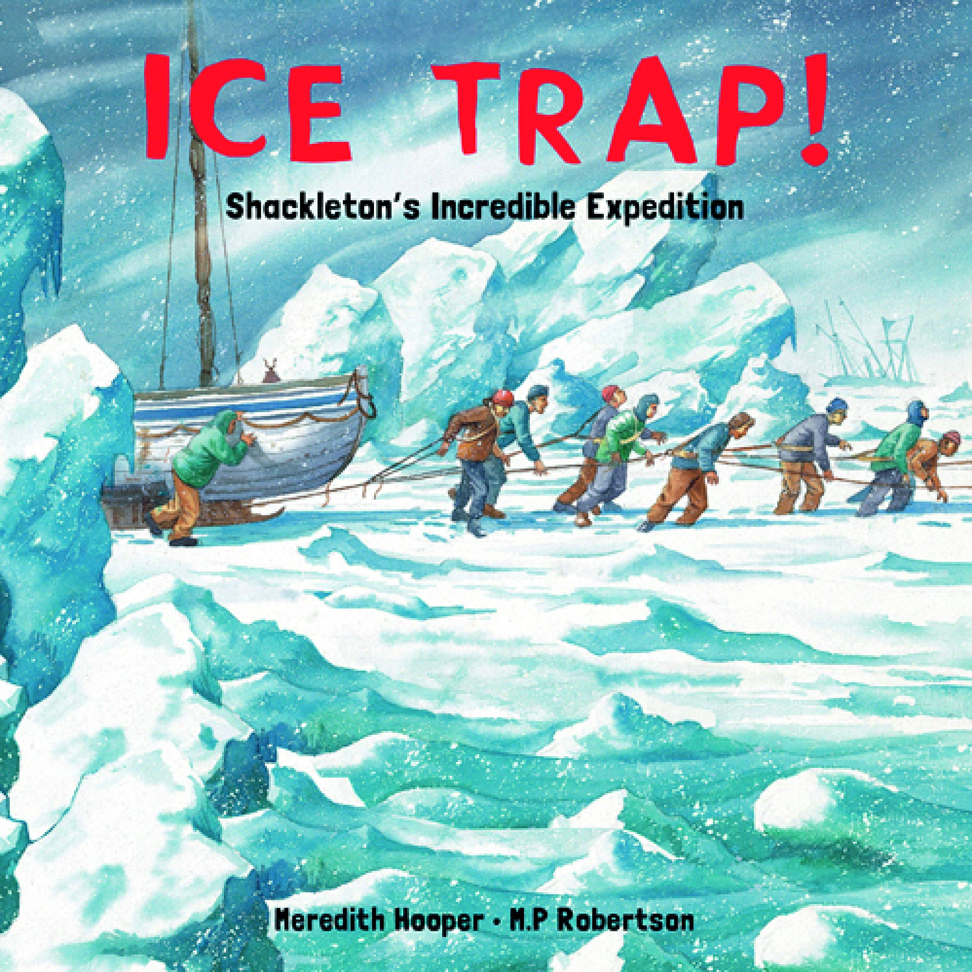
 | Writing Focus | Retell  Mark making  Shared writing | Signs & labels  Thought bubbles  Flyers  Letters  Adverts |  | Labels  Notes  Innovate alternative characters  Narrative | Thought bubbles  Labels  Oral retelling  Story maps | Labels & captions  Retelling  Leaflets  Story maps | Responses to illustrations  Writing in a role  Simple explanations
 | Phonic readers | Level 2a – Dig & Tap; Sip, Sip, Tip; Pat a Pig; Tap, Pat, Nap.  Level 2b – In the Bag; It is Hot; Len & ren; Tap & Bam; Hit & Miss; Hop to the Log; On the Bus; Off & On; The Sock; Get a Hat; Cats & Big Cats; Ben. | Level 2b – In the Bag; It is Hot; Len & ren; Tap & Bam; Hit & Miss; Hop to the Log; On the Bus; Off & On; The Sock; Get a Hat; Cats & Big Cats; Ben.  Level 2c – The Rug; The Map; In the Cockpit; A big Mud Mess; Gus the Gull; The Padlock; Lots of Fun! Bins, Bins, Bins!  Level 3a – We Can! Get that Cat! Will We Win? Fox at the Chops; Pop & Bang; Push, Pull, Bang! |  | Level 3a – We Can! Get that Cat! Will We Win? Fox at the Chops; Pop & Bang; Push, Pull, Bang!  Level 3b – A cure for Ben; All for Dad; At the Fair; Has a Goat got my Coat? Back on the Road, All Sorts of Dogs. | Level 3b – A cure for Ben; All for Dad; At the Fair; Has a Goat got my Coat? Back on the Road, All Sorts of Dogs.  Level 3c – Chicks on the Run; At the Airport; On the Top; Hang on! All sorts of Diggers; Farm to Yarn | Level 3c – Chicks on the Run; At the Airport; On the Top; Hang on! All sorts of Diggers; Farm to Yarn  Level 4a – Fun at the Pool; A Trip in a Rocket; Haircuts; Sal the Seed; All sorts of Shops; In the Bug Hut | Level 4a – Fun at the Pool; A Trip in a Rocket; Haircuts; Sal the Seed; All sorts of Shops; In the Bug Hut  Level 4b – Steg & the egg; One Night in the Tent; Jet the Vet; The Midnight Bop; Poop for Lunch; All sorts of Hair  Level 4c – Soon, Little One, Soon; My Shell is too Tight! Training Ben; Kit is not well; Rain, Sun & Lots of Fun! Up at Night
 | Phonics | s, a, t, p,  i, n, m, d,  g, o, c, k,  ck, e, u, r  h, b, f, l,  ff, ll, ss  to the no go I | j, v, w, x,  y, z, zz, qu, ch,  sh, th, th, ng  ai, ee, igh, oa  oo, oo, ar, or  he, she, we, me, be, was, my, |  | ur, ow, oi, ear  air, er  Recap j-oa  Recap oo – er  you, they, here, all are | Trigraphs & Constant digraphs  Letter sounds & vowel digraphs  Revision of all level 2/3 tricky words | cvcc words  ccvc words  adjacent consonants  Polysyllabic words  Three-letter adjacent consonants  said, so, have, like, some, come, were, little, one, do, when, out, what
Year 1 | Core Text | 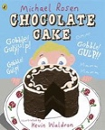 | 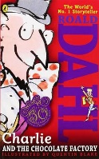 |  |  | A range of traditional tales  - Cinderella  - Snow White  - 3 Billy goats Gruff  - Hansel & Gretel  - Baba Yaga |  | 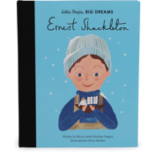
 | Speaking & Listening | Listen & respond appropriately to adults and their peers. Ask relevant questions to extend their understanding and knowledge. Use relevant strategies to build their vocabulary. Articulate & justify answers, arguments and opinions. Give well structured descriptions, explanations and narratives for different purposes, including expressing feelings. Maintain attention and participate actively in collaborative conversations, staying on topic and initiating and responding to comments. Use spoken language to develop understanding through speculating, hypothesising, imagining and exploring ideas. Speak audibly and fluently with increasing command of Standard English. Participate in discussions, presentations, performances, role play, improvisations and debates. Gain, maintain and monitor the interest of the listener(s). Consider & evaluate different viewpoints, attending & building on the contributions of others. Select & use appropriate registers for effective communication.
 | Guided Reading Text | 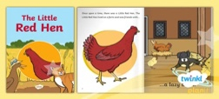  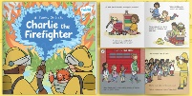 |  | 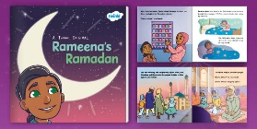  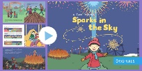 | 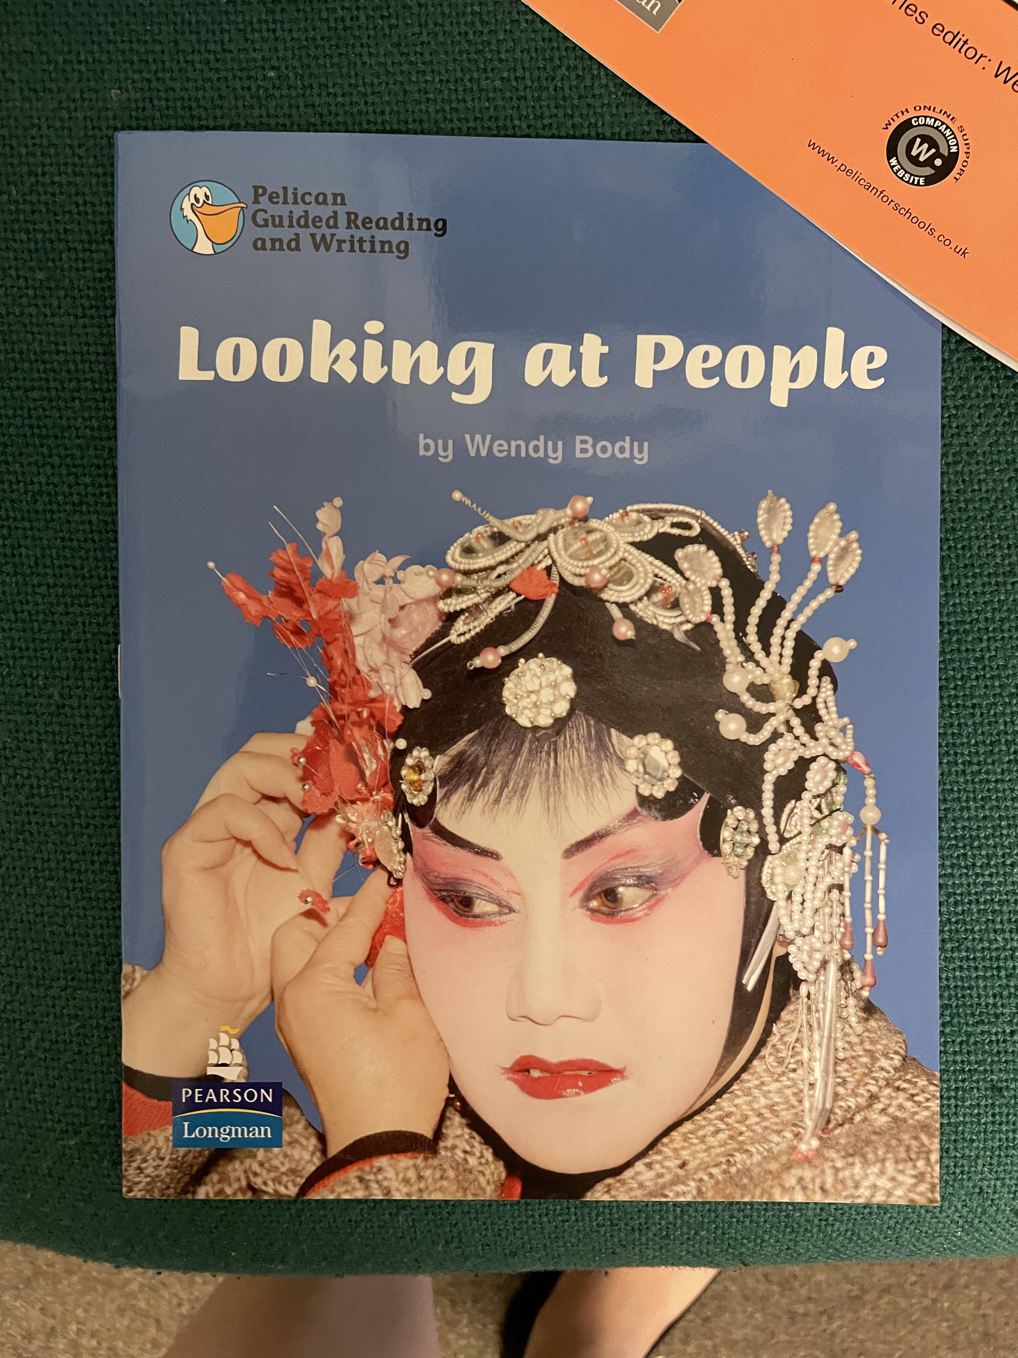  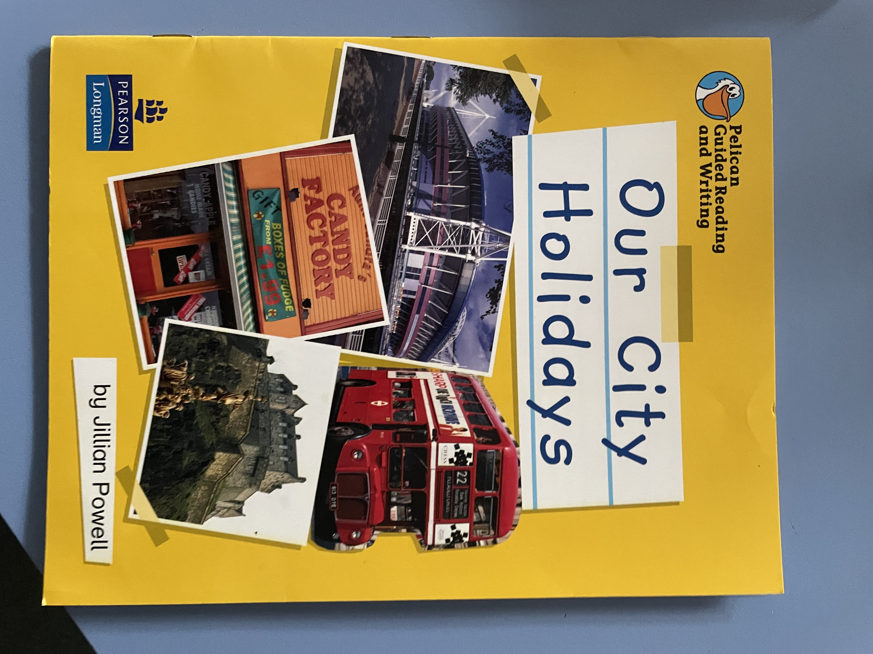 | 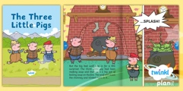 | 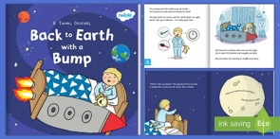 | 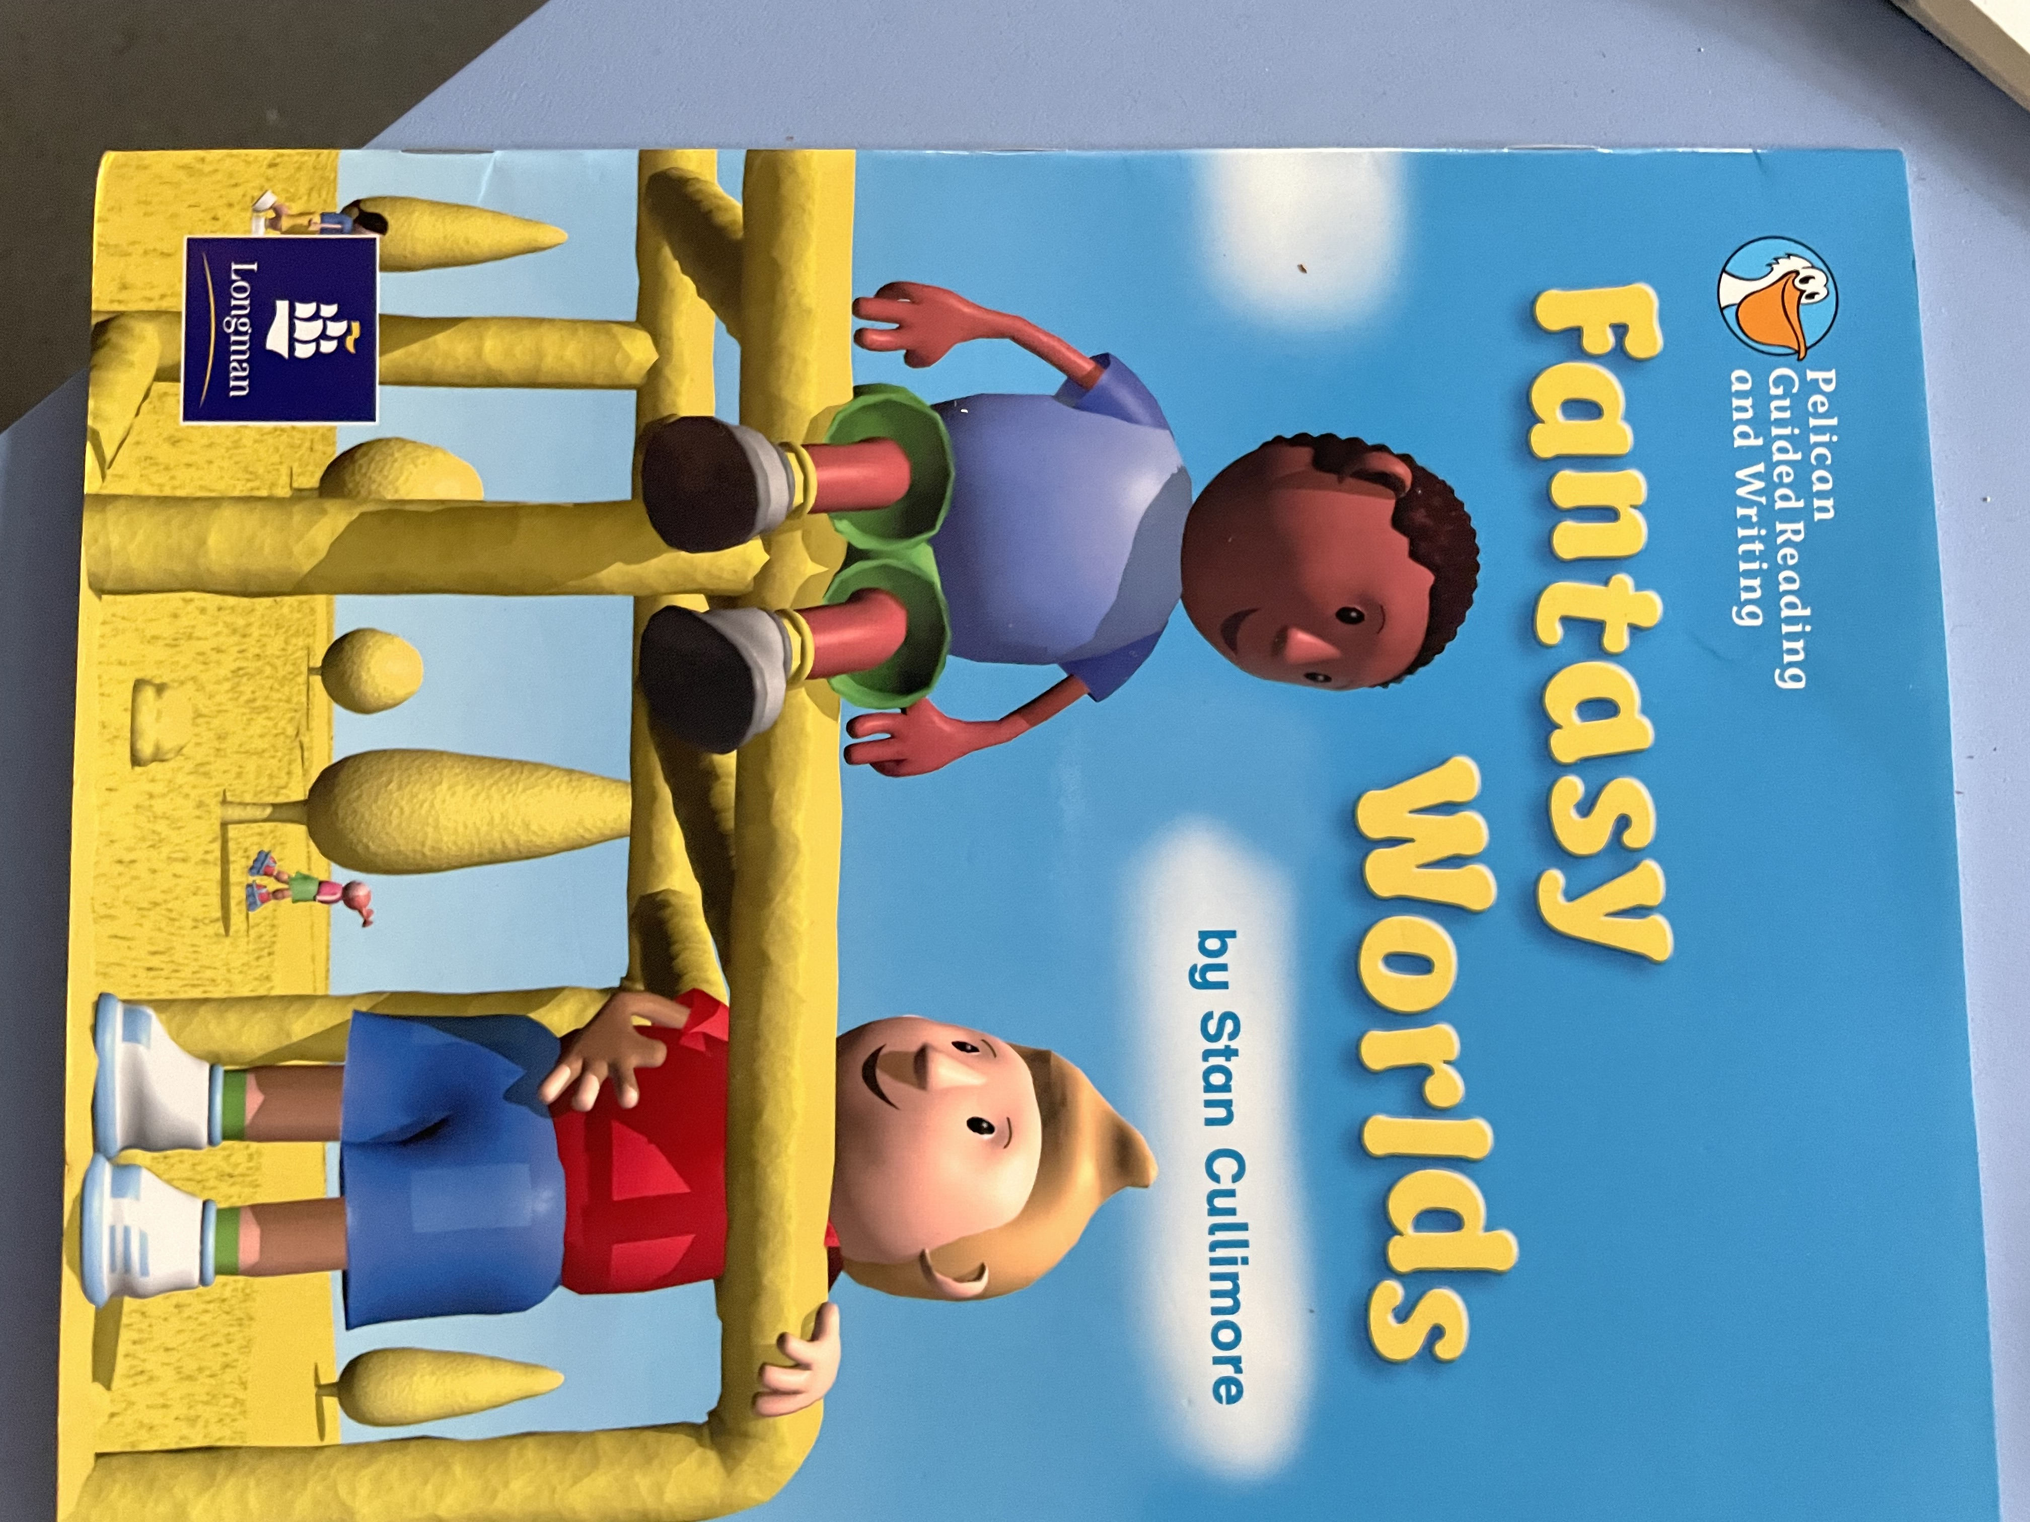  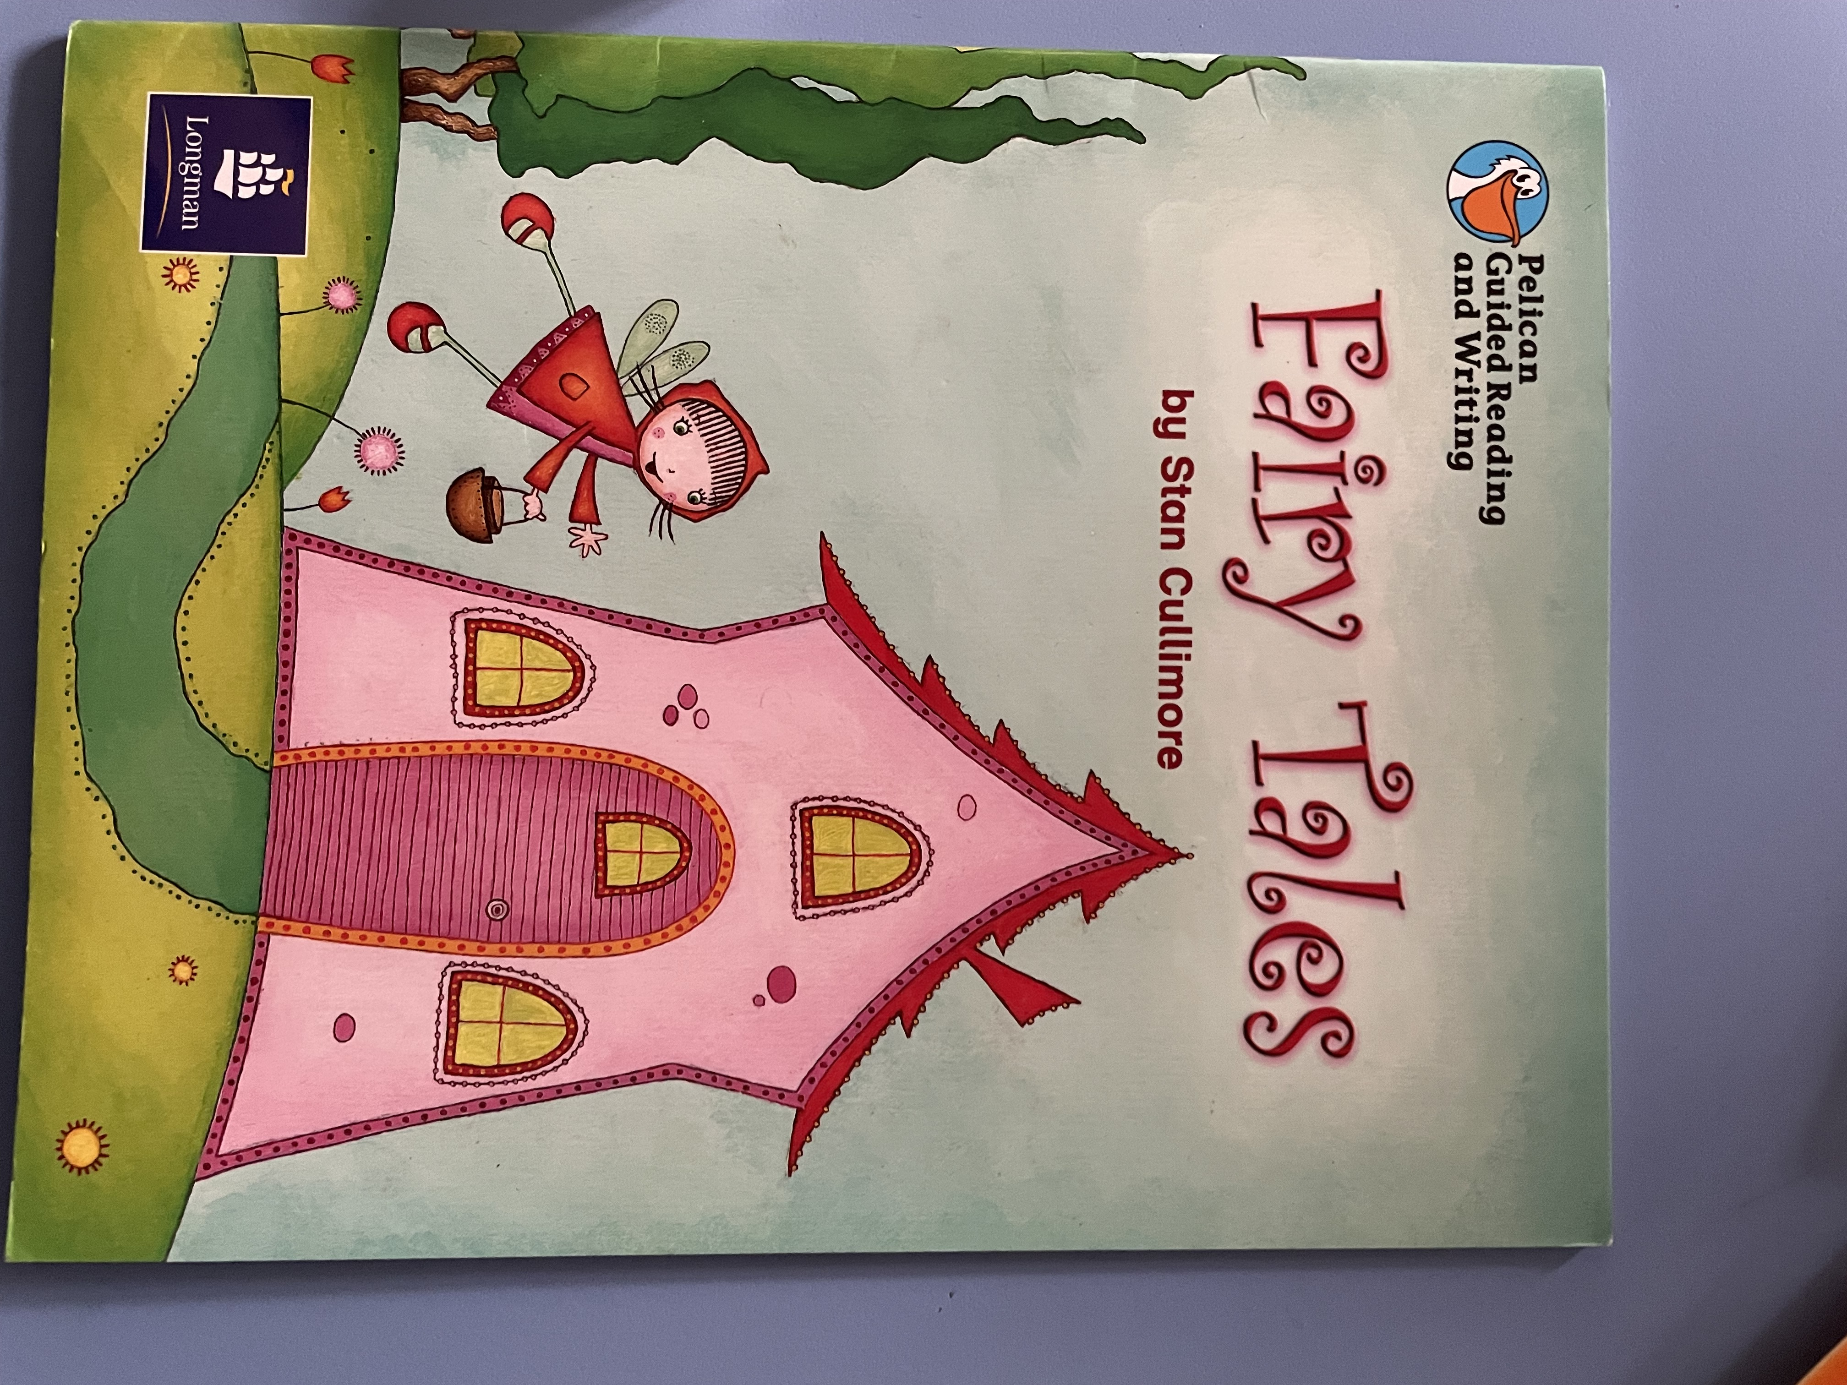
 | Phonics Readers | Level 4b – Steg & the egg; One Night in the Tent; Jet the Vet; The Midnight Bop; Poop for Lunch; All sorts of Hair  Level 4c – Soon, Little One, Soon; My Shell is too Tight! Training Ben; Kit is not well; Rain, Sun & Lots of Fun! Up at Night | Level 4c – Soon, Little One, Soon; My Shell is too Tight! Training Ben; Kit is not well; Rain, Sun & Lots of Fun! Up at Night  Level 5a – Mr Gale’s Garden; Robot Rick & the toys at Night; On your Marks, Kit & Sam! Come into the Woods: The Big Sports Quiz; The Old Toy Shop |  | Level 5a – Mr Gale’s Garden; Robot Rick & the toys at Night; On your Marks, Kit & Sam! Come into the Woods: The Big Sports Quiz; The Old Toy Shop  Level 5b – Jay’s Day at the Park; The Best Chef; How to Spot Birds Near You; Your Body From Top to Toe; All Sorts of Homes; My Tooth is Hurting! | Level 5b – Jay’s Day at the Park; The Best Chef; How to Spot Birds Near You; Your Body From Top to Toe; All Sorts of Homes; My Tooth is Hurting! | Level 5b – Jay’s Day at the Park; The Best Chef; How to Spot Birds Near You; Your Body From Top to Toe; All Sorts of Homes; My Tooth is Hurting!  Level 5c – Please, Leave Me Alone! A Magical Trip to Scotland; Do Elephants Wear Sunscreen? Tails, Tails, Tails! Witchety Snitchety! The Class Photo | Level 5c – Please, Leave Me Alone! A Magical Trip to Scotland; Do Elephants Wear Sunscreen? Tails, Tails, Tails! Witchety Snitchety! The Class Photo
 | Phonics | ay, oy, ie, ea, a-e, i-e, o-e, u-e, e-e  could, should, would want, oh, their, Mr, Mrs, love, your, people, looked, called, asked | ou, long vowel sounds, ch saying c & sh, ir, ue, ew  water, where, who, why, thought, through, work, house, many, laughed, because, different |  | y saying ee, aw, au, ow and oe saying oa, wh, c saying s, g saying j  any, eye, friend, also, once, please, live, coming, Monday, Tuesday | ph, ea, ie, +ed, +s/es,  Wednesday, brother, more, before, January, February, April, July, scissors, castle | +er, + est, tch, +ing, ear & are saying air, Unspoken e,  beautiful, treasure, door, floor, favourite, bought, autumn, gone, know colour | ore, un+,  other, does, talk, two
 | Writing Focus/Genres | Poetry  Narrative  Character descriptions  Explanations | Non-Fiction – Instructions/recipes  Narrative  Informal letter  Diary Entry  Character descriptions  Adverts |  | Factual descriptions (London)  Persuasive letter  Guidebook (A walk in …)  Recounts  Leaflets | Own Version narrative Short stories  Missing/Wanted posters  Scripts | Adventure Stories  Postcards  Information texts | Letters – Formal/Informal  How to Guides  Fact Files  Recounts
 | NC Writing objectives | Write sentences by saying aloud what they are going to write about.  Compose sentences orally before writing it.  Sequence sentences to form short narratives.  Re-read what they have written to check it makes sense.  Discuss what they have written with the teacher or other pupils.  Read aloud their writing clearly enough to be heard by their peers and the teacher.
 | Reading Skills | Give/explain the meaning of words in context.  Draw on vocabulary to understand texts.  Predict what might happen on the basis of what has been said and done. | Give/explain the meaning of words in context.  Draw on vocabulary to understand texts.  Retrieve and record details from fiction.  Make inferences from the text/ explain and justify inferences with evidence from the text.  Predict what might happen on the basis of what has been said and done. |  | Give/explain the meaning of words in context.  Retrieve and record information/identifying key details from fiction and non-fiction.  Summarise main ideas from more than one paragraph  Make inferences from the text/ explain and justify inferences with evidence from the text.  Predict what might happen on the basis of what has been said and done. | Give/explain the meaning of words in context.  Retrieve and record information/identifying key details from fiction and non-fiction.  Summarise main ideas from more than one paragraph  Make inferences from the text/ explain and justify inferences with evidence from the text.  Predict what might happen on the basis of what has been said and done. | Give/explain the meaning of words in context.  Retrieve and record information/identifying key details from fiction and non-fiction.  Summarise main ideas from more than one paragraph  Make inferences from the text/ explain and justify inferences with evidence from the text.  Predict what might happen on the basis of what has been said and done. | Give/explain the meaning of words in context.  Retrieve and record information/identifying key details from fiction and non-fiction.  Summarise main ideas from more than one paragraph  Make inferences from the text/ explain and justify inferences with evidence from the text.  Predict what might happen on the basis of what has been said and done.
 | Handwriting | Letter formation, correct size, relative to one another  Ladder Family | One armed robot family |  | Zigzag monster Family | Curly caterpillar family  (c a o d g q) | Curly caterpillar family  (e, s , f) | Consolidation
 | Grammar & Punctuation Focus | Capital letter & Full Stops  Capital letters for people, places and personal pronoun – I  Noun phrases  Joining words and clauses using and | Leaving spaces between words  Joining words and clauses using and  Punctuate sentences using a capital letter and full stop, question mark, or exclamation mark  Capital letters for people, places and personal pronoun – I  Expanded noun phrases  Commas in a list |  | Leaving spaces between words  Joining words and clauses using and  Punctuate sentences using a capital letter and full stop, question mark, or exclamation mark  Capital letters for people, places and personal pronoun – I  Expanded noun phrases  Sequencing sentences to form short narratives | Capital letters for Days of the Week.  Present/Past tense  Subordination  Co-ordination  Punctuate sentences using a capital letter and full stop, question mark, or exclamation mark  Capital letters for people, places and personal pronoun – I | Regular plural noun suffixes s/es  Apostrophes for contraction and singular possession  Sequencing sentences to form short narratives | Capital letters for Days of the Week.  Present/Past tense  Subordination  Co-ordination  Regular plural noun suffixes s/es  Apostrophes for contraction and singular possession  Sequencing sentences to form short narratives
 | Spelling  Focus | Linked to phonics  said, so, have, like, some, come, were, there, little, one, do, when, what could | Linked to phonics  Should, would, want, their, Mr, Mrs, love, your, people, looked, asked, called |  | Linked to phonics  water, where, who, why, thought, through work, house, many laughed | Linked to phonics  because, different, any, eye, friend, also, please, once, live, coming | Linked to phonics  Monday, Tuesday, Wednesday, brother, more, before, January, February, April July, | Linked to phonics  scissors, castle, beautiful, treasure
 | Core Text | 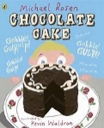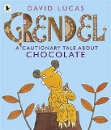 |  |  |  | A range of traditional tales  - Cinderella  - Snow White  - 3 Billy goats Gruff  - Hansel & Gretel  - Baba Yaga
 | Speaking & Listening | Listen & respond appropriately to adults and their peers. Ask relevant questions to extend their understanding and knowledge. Use relevant strategies to build their vocabulary. Articulate & justify answers, arguments and opinions. Give well structured descriptions, explanations and narratives for different purposes, including expressing feelings. Maintain attention and participate actively in collaborative conversations, staying on topic and initiating and responding to comments. Use spoken language to develop understanding through speculating, hypothesising, imagining and exploring ideas. Speak audibly and fluently with increasing command of Standard English. Participate in discussions, presentations, performances, role play, improvisations and debates. Gain, maintain and monitor the interest of the listener(s). Consider & evaluate different viewpoints, attending & building on the contributions of others. Select & use appropriate registers for effective communication.
Year 2 | Guided Reading Text | 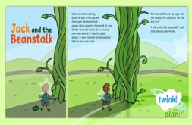 | 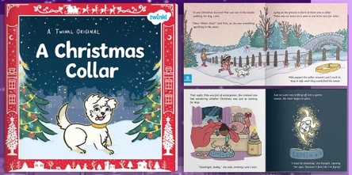 |  | 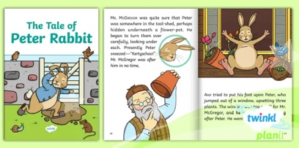 |  | 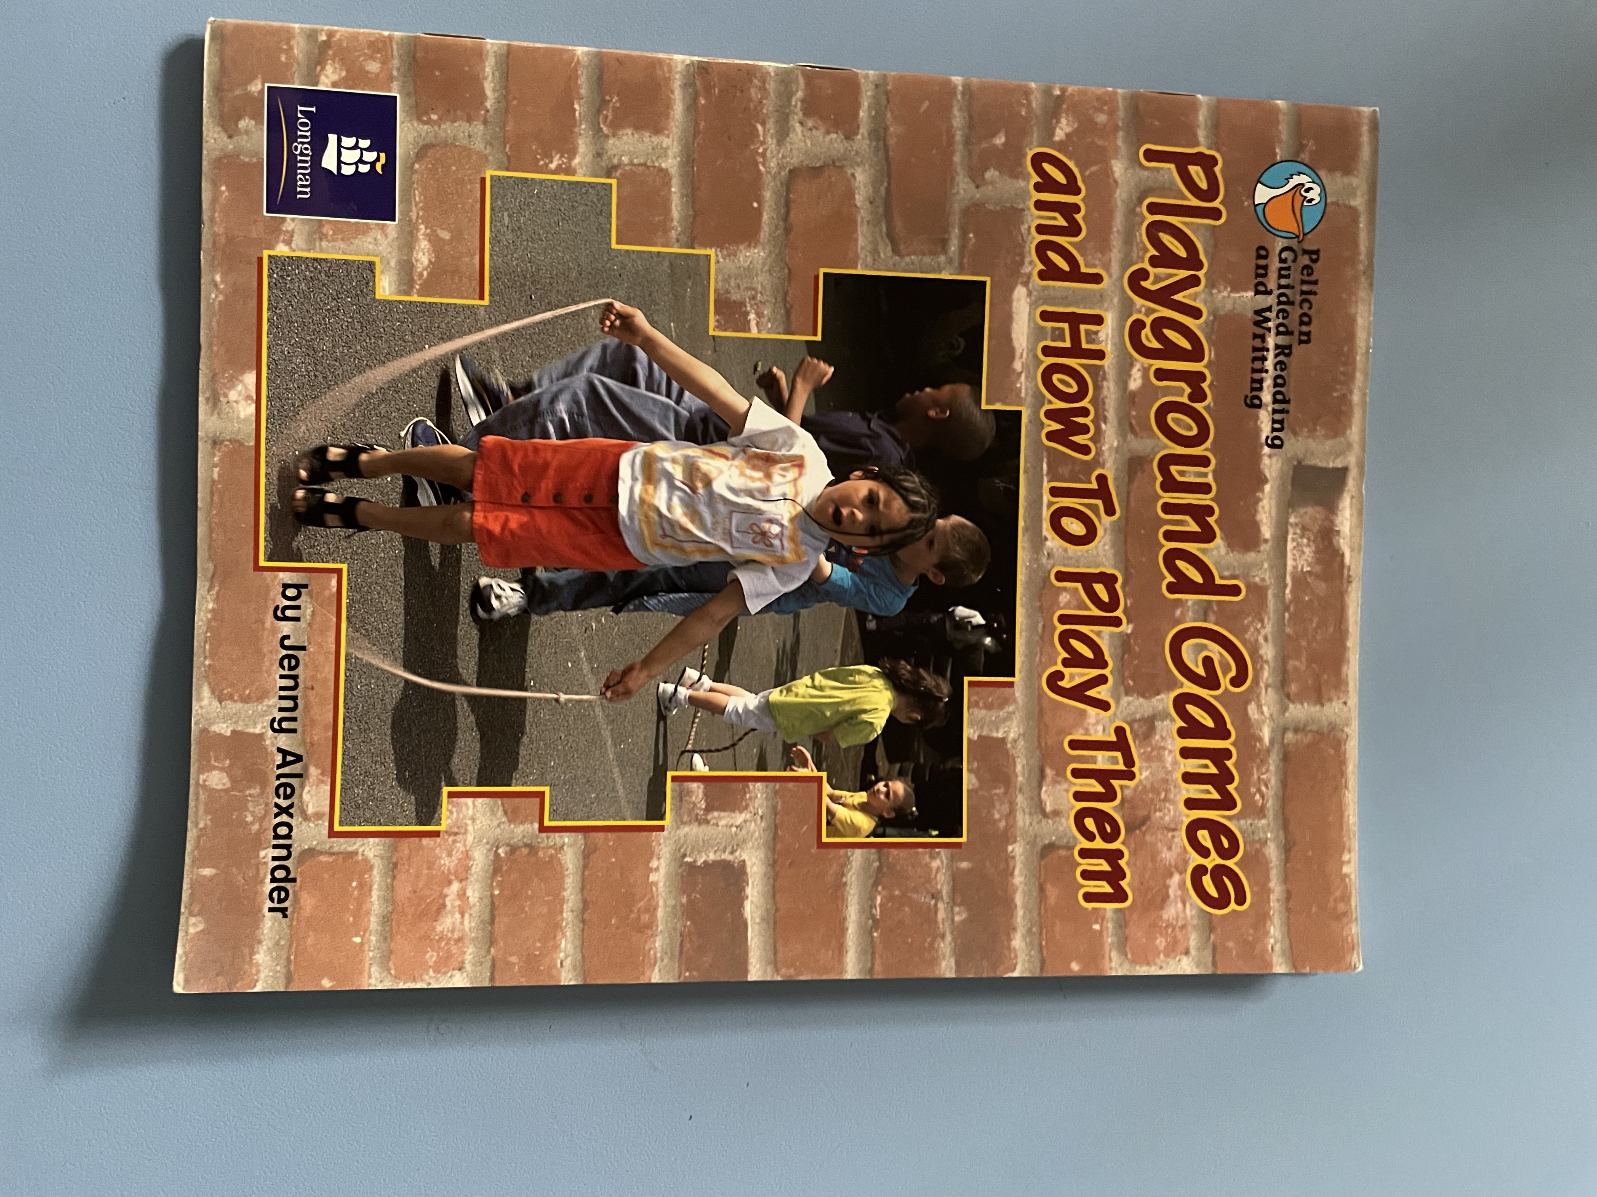 | 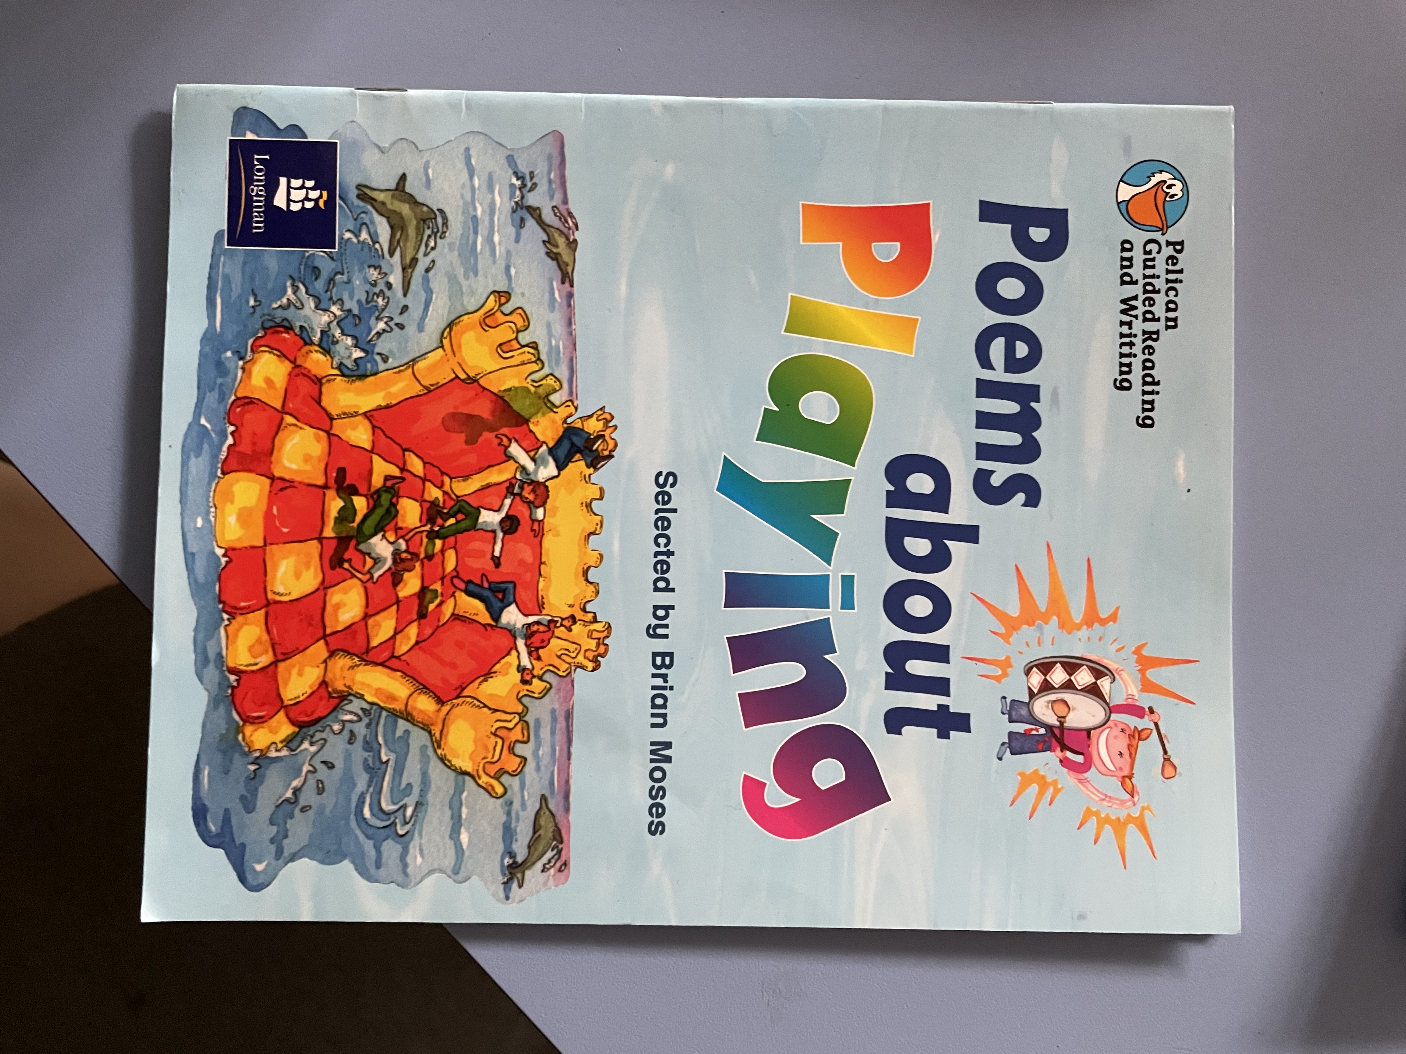
 | Phonics Readers | Level 5c – Please, Leave Me Alone! A Magical Trip to Scotland; Do Elephants Wear Sunscreen? Tails, Tails, Tails! Witchety Snitchety! The Class Photo | Level 5c – Please, Leave Me Alone! A Magical Trip to Scotland; Do Elephants Wear Sunscreen? Tails, Tails, Tails! Witchety Snitchety! The Class Photo  Level 6a – A Rubbish Day at the Beach; The Big World Record Attempt; The Great Under the Sea Quiz; How to make a Paper Rocket; Wanted! Rat-Cather (& other Medieval Jobs); The 3 Trolls & the Big Bad Goat |  | Level 6a – A Rubbish Day at the Beach; The Big World Record Attempt; The Great Under the Sea Quiz; How to make a Paper Rocket; Wanted! Rat-Cather (& other Medieval Jobs); The 3 Trolls & the Big Bad Goat  Level 6b – A Colourful Festival; Where in the World Can You Find…? Fire! Fire! A Time Ship Adventure; Sam’s Street Party; Wild About Plants! The Magic Porridge Pot | Level 6b – A Colourful Festival; Where in the World Can You Find…? Fire! Fire! A Time Ship Adventure; Sam’s Street Party; Wild About Plants! The Magic Porridge Pot | Level 6b – A Colourful Festival; Where in the World Can You Find…? Fire! Fire! A Time Ship Adventure; Sam’s Street Party; Wild About Plants! The Magic Porridge Pot  Level 6c – The Big Buzz; Wild World: Wild Facts; Bees are Brilliant; A Handbook to Life on Earth; The Wolf Who was Afraid of the Light; The Ants and the Grasshoppers | Level 6c – The Big Buzz; Wild World: Wild Facts; Bees are Brilliant; A Handbook to Life on Earth; The Wolf Who was Afraid of the Light; The Ants and the Grasshoppers
 | Writing focus/Genres | Poetry  Narrative  Character descriptions  Explanations | Non-Fiction – Instructions/recipes  Narrative  Informal letter  Diary Entry  Character descriptions  Adverts |  | Factual descriptions (London)  Persuasive letter  Guidebook (A walk in …)  Recounts  Leaflets | Own Version narrative Short stories  Missing/Wanted posters  Scripts | Adventure Stories  Postcards  Information texts | Letters – Formal/Informal  How to Guides  Fact Files  Recounts
 | NC writing objectives | Develop positive attitudes towards and stamina for writing by: writing narratives about personal experiences and those of others (real & fictional), writing about real events, writing poetry, writing for different purposes.  Consider what they are going to write before beginning by: planning or saying out loud what they are going to write about, writing down ideas and/or key words, including new vocabulary, encapsulating what they want to say, sentence by sentence.  Make simple additions, revisions and corrections to their own writing by: evaluating their own writing with the teacher and other pupils, re-reading to check their writing makes sense and that verbs to indicate time are used correctly and consistently, including verbs in the continuous form, proofreading to check for errors in spelling, grammar and punctuation, read aloud what they have written with appropriate intonation to make the meaning clear.
 | Reading Skills | Give/explain the meaning of words in context.  Draw on vocabulary to understand texts.  Predict what might happen on the basis of what has been said and done. | Give/explain the meaning of words in context.  Retrieve and record information/identify key details from fiction (and non fiction)  Summarise main ideas from more than one paragraph.  Make inferences from the text/explain and justify inferences with evidence from the text.  Predict what might happen on the basis of what has been said and done. |  | Draw on vocabulary to understand texts.  Identify/explain key aspects of fiction/non-fiction.  Identify and explain sequence of events in texts.  Make inferences from text.  Predict what might happen on the basis of what has been said and done. | Give/explain the meaning of words in context.  Retrieve and record information/identify key details from (fiction) and non fiction  Summarise main ideas from more than one paragraph.  Make inferences from the text/explain and justify inferences with evidence from the text.  Predict what might happen on the basis of what has been said and done. | Draw on vocabulary to understand texts  Identify/explain key aspects of fiction/non-fiction.  Identify and explain sequence of events in texts.  Make inferences from text.  Predict what might happen on the basis of what has been said and done. | Give/explain the meaning of words in context.  Retrieve and record information/identify key details from (fiction) and non fiction  Summarise main ideas from more than one paragraph.  Make inferences from the text/explain and justify inferences with evidence from the text.  Predict what might happen on the basis of what has been said and done.
 | Handwriting | Individual letter formation | Joining ladder letters |  | Joining robot letters | Joining curly caterpillar letters | Joining zigzag monster letters | Fluent joining
 | Grammar & Punctuation Focus | Capital letter & Full Stops  Capital letters for people, places and personal pronoun – I  Noun phrases  Joining words and clauses using and  Spaces between words | Regular plurals  Capital letter, full stops, exclamation mark, question mark  Capital letters for people, places and personal pronoun – I, days of the week, months of the year  Present/past tense  Sub-ordination/co-ordination  Expanded noun phrases  Apostrophes for contraction and possession  Commas in a list |  | Sub-ordination/co-ordination  Capital letter, full stops, exclamation mark, question mark  Capital letters for people, places and personal pronoun – I, days of the week, months of the year  Expressing time, place and cause using conjunctions  Expanded noun phrases  Past/present progressive tense | Expanded noun phrases to describe and specify  Apostrophes for contraction and possession  Sentence types and correct demarcation | Past/present tense including the progressive tense – correct choice and consistent use  Sentence types and correct demarcation  Apostrophes for contraction and possession | Reinforcement and consolidation
 | Spelling  Focus | y saying igh  dge/ge saying j  +es to words ending in y  gn for n  kn for n  +ed & +ing to words ending in y  wr saying r  door, floor, bought, favourite, autumn, gone, know, colour, other, does, talk, two, four, eight | el, al, il,  +ed & er to words ending in e  eer  ture  +est & y to words ending in y  break, steak, busy, clothes, whole, listen, build, earth, delicious, fruit, learn, search |  | mb  a & al saying or  +ing & +ed to CVC & CCVC words  o saying u  ey saying ee  famous, shoe, pretty, neighbour, England, tongue, group, country, heart, dangerous | +er, +est or +y to CVC and CVCC words  contractions  war saying wor  wor saying wur  +ment  +ness  special, enough, aunt, father, prove, improve, hour, move, | s saying zh  wa saying wo  qua saying quo  tion  +ful  +less  +ly  sure, sugar, half, quarter, straight, touch, caught, daughter, | Homophones  Near Homophones  dis+  journey, area, heard, early

