Key Stage 1  English Learning Journey  Outcome:  Purpose: To inform  Audience: Paddington  Form: Recounts – diary  Purpose: To persuade  Audience: Their parents  Form: Factual descriptions/leaflets (year 1)  Factual descriptions (London)/ Guidebook (A walk in …)  (year 2) | 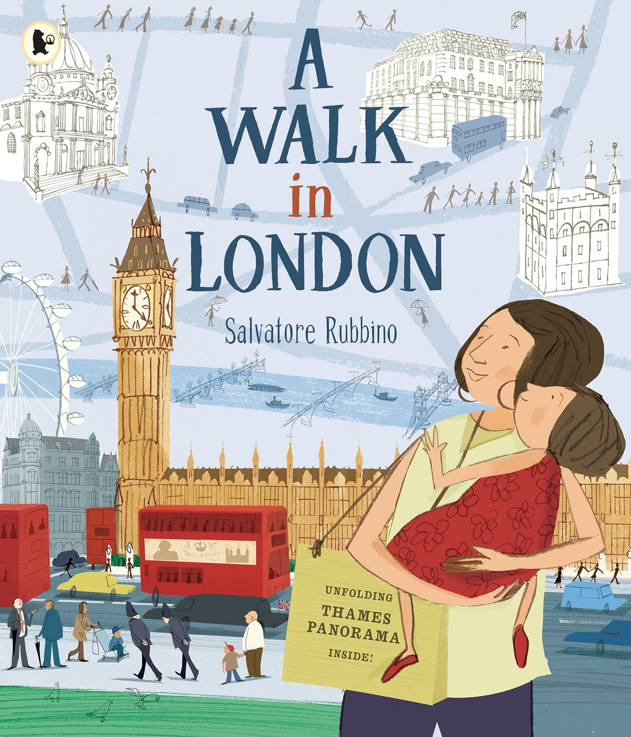  Text: | Key Writing Statements  - Write for a purpose  - Compose and write simple sentences with a capital letter and a full stop  - Use relevant vocabulary  Develop positive attitudes towards and stamina for writing by:  - Writing for different purposes  - Starting to use paragraphs  Consider what they are going to write before beginning by:  - Planning or saying out loud what they are going to write about  Make simple additions, revisions and corrections to their own writing by:  - Proof reading to check for errors in spelling, grammar, and punctuation  Key Reading Statements  - Read and talk about own writing  - Show an awareness that texts for different purposes look different  - Read further exception words, noting the unusual correspondence between spelling and sound and where these occur.  Develop pleasure in reading, motivation to read, vocabulary and understanding by:  - Listen to and discuss a wide range of fiction, poetry, plays, non-fiction and reference books or textbooks.  - Be introduced to non-fiction books that are structured in different ways.  Understand both the books they can already read accurately and fluently and those they listen to by:  - Answering and asking questions  - Using dictionaries to check the meaning of words that they have read
Linked Guiding Reading Texts
Yr 1 – Our City Holidays
Yr 2 – The tale of Peter Rabbit

Overview of Learning Journey – Recount/Diary
Stimulate & Generate | Capture, Sift & Sort | Create, Refine, Evaluate
LO: To listen to and discuss a story  LO: To review a story  Look at front cover and blurb and discuss. What do you already know? Read the Ch 1 of A Bear called Paddington. Discuss characters and plot. Then read Paddington at the Palace.  Look through information about the author on the slides. Model how to write a book review using the boxes on the slides – what happened, who were the characters, favourite past and drawing a picture before giving it a rating out of 10. Children write their own book review using the book review template.  Templates with sentence starters. Word mats available with key words from story.  LO: To memorise a section of text  Introduce children to modal diary entry text. Children spend time creating actions to the picture map. Rehearse a few times as a group until the words are mainly memorised.  Children practise in partners using their own text maps. Mixed ability partners to rehearse.  Adult support by circling room and assisting where necessary  LO: To know what a diary is  Go through the features of diary entries – what do children already know about diaries? Go through lesson slides showing the different features and use of a diary and the type of writing. Place various types of writing around the room – instructions, stories, information and diary entries. Can the children locate the diary entries and explain how they know it is a diary based on the features discussed.  Adults circulate and support conversations  LO: To recognise time connectives  Look through lesson slides and remind children about time connectives looked at last term. Discuss why we might need them for a diary entry too?  Think of an adventure Paddington might go on – link to other Paddington stories read at story times or link to Geography work on London landmarks he could visit, brainstorm some ideas for a diary entry.  Model task – children write a mini diary entry for Paddington using 5 sentence starter time connectives as prompts.  Word banks and sentence starters to finish | LO: To write in the first person  Go through lesson slides discussing what 1st person writing is. Can children say an example sentence in 1st, 2nd, & 3rd person to a partner. Think about which person a diary is written in. Can the children verbally change the sentences into the 1st person. Model how to write a diary entry as Paddington using 1st person – go through word bank and rubric. Children write a diary entry from the perspective of Paddington writing in the 1st person about one of his adventures/days out. Children self assess their writing using the rubric previously discussed. Word banks, sentence templates,  LO: To recognise and use the past tense  Look at 2 sentences – one in present and one in past tense – in partners what is the difference? Which one is happening now? Which one has already happened? Explain what past tense is and show examples. Sort verbs into past/present. Discuss exception words. Can children change sentences from present to past tense? Children sort sentences. Children change present tense sentences about Paddington into past tense. Verb word banks  LO: To use conjunctions  Look at ‘boring’ sentences and explain that we need connectives to make them more interesting. Show three conjunctions – and, but, because. Recap subordinating and co-ordinating conjunctions. Children talk in partners to make the sentence ‘I ate a marmalade sandwich … more interesting by adding a conjunction to the end.  Children write the sentence I went to London and add a conjunction to improve and add to the sentence.  Sentence starters, word banks  LO: To recognise proper nouns, and use capital letters for proper nouns for names and places  Ask children to recall what a noun is. Remind children and ask if they can think of any examples? Watch video about proper nouns. Look at examples of proper nouns. In pairs children complete proper noun quiz. Children sort nouns into common and proper nouns. Paddington Editing task – read and correct Paddington’s diary checking that all the proper nouns have capital letters.Children write a sentence using a proper noun using the word mat. Use more than 1 proper noun  LO: To use adjectives to describe surroundings/settings  Discuss what a setting is. Look at example pictures of settings and recap expanded noun phrases. Brainstorm adjectives and nouns to match the setting pictures.  Show A3 pictures of settings out on tables, with post it notes and pens. Children walk around the room and add as many nouns/adjectives to the post it notes to the pictures.  Encourage Yr 2 children to write 2 adjectives per noun.  Read out and review the children’s descriptions.  Model how to write sentences describing a setting – using connectives from previous session and noun phrases from today. Children choose a setting to write descriptive sentences about.  LO: To use adjectives to describe feelings  Go through lesson presentation and explain how diaries are a place to express feelings about our day. Show 2 settings that children might walk past and write about in their diary. Using stem sentence ‘I feel … because’ children talk in partners to come up with ideas to fill in the blanks. Show children synonyms for key emotive words and explain how they will try to use them in their writing today. Modal how to use some of the new words to write a sentence. Children use feelings word bank to write their own emotive sentences.  Word bank, sentence starters. | LO: To gather ideas for diary entry  Tell the children that Paddington will be visiting a brand new place and they will be writing a diary entry about it from the point of view of Paddington. Brainstorm ideas of places he could visit, food he could eat, and ways he could travel around.  Children use templates to think of at least 3 ideas for each category – drawing and labelling their ideas.  LO: To plan a diary entry  Use story map template with missing boxes to model with the children on to fill them in to make a new diary entry for Paddington. Get children to come up with ideas after lots of partner talk. Orally say the new story map diary entry as a class. Children fill in their own story map by drawing pictures. Children spend time practising orally retelling their new diary entry.  LO: To share write a diary entry  Show list for a great diary entry - ask children to help add to it – adjectives, conjunctions, proper nouns, first person, past tense, time connectives.  Using previous session’s plan model to the children how to use the plan to write up the diary on large paper. Think out loud while doing it, making purposeful mistakes and getting children to brainstorm what the next sentence should be. (I do/We do)  LO: To write a diary entry  Children practise their story map orally again. Children write their own diary entry using their plan. Use word mats from previous sessions.  LO: To edit and improve a diary entry  Children use list created in earlier sessions to think about what they did well and model how to up level sentences and improve their text, children work in pairs to read and improve sentences in their own work.
Overview of Learning Journey – Leaflet/Guidebook
Stimulate & Generate | Capture, Sift & Sort | Create, Refine, Evaluate
LO: To recall facts in order  Recall information in order, use time adverbials, state facts  Display footprints on whiteboard or going across carpet and ask children, when was the last time you went for a walk? Discuss in pairs. Where did you go? What did you see? Using talking partners, ask children to share and talk about the places they have been. Take children on a walk around the school grounds. At certain points on your walk, stop and ask children to recall the places they have been so far. “First we passed...” “Then we walked through...” etc. Ask them to state a fact about the place they are standing in now. Once back in the classroom, create a bullet point list of all the places visited on the walk. Use talk partners to orally recount the walk - one partner to tell the story of the walk, the other to insert facts about the places visited.  Shared writing: Model drawing a map of the walk around the school, verbalising the thought process of recalling each place visited - The first place we walked to was the toilets. After that we visited the office. In pairs, children work together to draw a map of their walk around the school grounds. Encourage them to talk about their walk to practice the language of chronology/recount/narrative. Children may benefit from time adverbials on tables - First, Then, Next, After that, Last Using post-it notes, ask them to add one fact about each place they visited to their map. E.g.: The church is where the children come for assembly. At 10:40am it’s break time. Recall the words children used to order the journeys on their maps. Create a list of adverbials of time and display on the working wall for future reference.  LO: To identify the features of both recounts and information texts  Recognise and label the features of text types  Children arrive into class to find a letter from Paddington asking them to write a guide on the local area so he can visit. The letter should state that there have been many guides written over the years, but none of them have appealed or been interesting enough. Tell them that you have read a book recently that presents information in an interesting way. Introduce the book A Walk in London and spend time reading and studying the information presented. What is special about how the book is presented? How could we make our tour guide more interesting? Generate a list of initial ideas.  Children to have copies of the book on the table and work in pairs become tour guides for one particular area – practise the tone of voice a tour guide might use. Did you know... You won’t believe... If you want to... You will find... Can they use the same tone of voice to state the facts about their own walk around the school grounds? Look at various types of books that represent information in different ways. Have examples of books that present information with a narrative as well.  LO:To use positional vocabulary in sentences  Identify adverbial phrases for when or where, use prepositions, use adverbial phrases to begin sentences  Read the text again but this time focus on the narrative recount. Have phrases ‘fall out’ of the book on strips  of paper - these should be adverbials of time and  place. For example: In the yard, After the ceremony, From this spot, Round the corner, In the display cases, Nowadays, Back on land> In pairs sort them on whiteboards into those that signify where and those that signify when. Put onto the working wall. Can children think of any other phrases to describe time or place? Use sentence strips to begin writing positional sentences based on children’s walk around school. Ask children to choose an adverbial and write it on a post-it note to begin their sentence. In pairs, children complete their sentence using their maps. Around the corner is …  Provide a word bank with some positional vocabulary (prepositions) – under, around, across, behind, round, after etc. on tables to support. Look at the adverbials created and explain to children that these are fronted adverbials, i.e. those that would be placed at the opening of a sentence. Look  back at the phrases in the book and identify where the comma is placed to demarcate the sentence. Can children add a comma in the appropriate place to their sentences? | LO: To recount events sequentially  Orally recount events in the order that they took place  Organise a trip to the local area. Tell children that we are going to go on the walk twice; once to write as a recount, and once to find out facts about the places. On the walk, repeat the process from session 1, stopping to recall places visited so far and orally recounting to a partner. There will be no need to focus on stating facts at this stage. children to draw a map of their walk as they go and label the places they have visited. Ensure that cameras are taken and ask children to take photos of the main landmarks visited. Try to include some events, such as having a picnic, or a football game. Recount events in order on return. Use a talk circle to facilitate this and split into smaller circles.  LO: To plan a recount in order of time  Recount events in order orally, record events in order using a planner, use adverbials for when and where  Using maps and photos taken, recount the trip orally. Model this referring to the adverbial phrases for where and when displayed on the working wall. Children to recount the trip with a partner. Model how to organise events on to an arrow planner ready for writing. Focus only on ‘events’ side for now, facts will be filled out in a future session. Children to use maps and photos, as well the teacher model, to plan a recount of their trip.  First, we went to the park. Around the corner was the telephone box. Children to orally retell their recount to a partner using their arrow planner as a guide.  Have I missed anything out?  LO: To recount events sequentially using full sentences  Recount events in order, use adverbial phrases to indicate where or when an event is taking place, know when to start a new section  Use arrow planner to model writing a recount with a focus on cohesion and identifying where to start a new paragraph, e.g. for a change of place or time, using adverbial phrases to demarcate this.  First, we stopped at the park and played in the playground. The best part was whizzing down the slide!  Around the corner from the park, was the … Write a recount of the trip in full sentences. Children to use a different paragraph for each time or place and adverbial phrases to indicate time and place. Ask children to work in pairs, reading each other their work. See if they can identify when the paragraph change takes place.  Have some children attempted to use commas after adverbial phrases?  LO: To ask questions that will give specific answers  Ask questions that will give factual answers, use a range of question types, use question marks  Tell children that today they’re going to focus on collecting facts about their place of focus. Look at the book A Walk in London again, specifically at the facts on each page. Model asking the types of questions that would lead to the answers stated. For example:  There has been a cathedral on this site for over 1400 years. The question could be - How long has there been a cathedral here for? Ensure to model the correct use of a capital letter and question mark. Provide photographs of last week’s trip to remind children of the places they are asking questions about. Share questions and sort into Who, What, Why, When, How. Which ones do you have the most/least of? What do we most want to find out?  LO: To use questions to identify facts about a specific place  Ask questions, find answers to specific questions, scribe answers in note form  Arrange for the second trip to a local place. This time tell children they are on a fact-finding mission. Prior to trip, ask children to select their favourite three questions and record/stick post-it notes on to their clipboards to take with them.  Model briefly how to make notes without writing whole sentences. Park has three swings. Lots of cars in car park. Repeat the trip for a second time. Children to have questions on clipboards. Have pictures available for children to spot on the walk so that they can identify some of the key places that might be of interest – culturally or historically. Also encourage children to draw the places as these will serve as illustrations in their guides. On return from the trip, children to share facts.  What was the most interesting thing you found out?  LO: To research answers to questions about a specific area  Use resources to find answers, adapt questions, record answers in brief notes  Recall second trip to the local place of interest. What questions did we want to find out the answers to? Were there any questions we couldn’t find the answers to? Why couldn’t we find the answers? Where else could we look? Model how to use resource books and the internet to find facts for unanswered questions. Using non-fiction books or the internet in the classroom, children to research answers to unanswered questions and record answers on clipboards. Some children may wish to edit their questions if they are unsuccessful in finding an answer. This will be good practice in asking specific questions. What new information did we find out? Share with others in the class  LO: To identify the difference between a question, statement and command  Know the difference between a question, statement and command, match questions and statements  read out sentences and phrases from A Walk in London and children to identify whether they are questions, commands or statements. Alternatively, this could be a sorting activity on tables. Why would we be unlikely to find a command in this book? Model writing up questions, with correct demarcation, and corresponding answers written as statements:  What year was Village park built? Village park was updated in 2012. Children to write up their facts from yesterday onto big pieces of paper alongside the corresponding questions. When would we use the questions? Discuss these are used by authors to draw the reader in and to present information in an accessible format. What is the difference in punctuation between a statement and a question? | LO: To plan writing using a skeleton structure  Plan factual section of guidebook, match facts to appropriate sections  Explain to children that this week they are going to combine their writing completed in last two weeks to make a book, ‘A Walk in ...’ Look back at A Walk in London and identify how the text is split up into recount and facts.  Model how to organise facts collected on to the arrow planner. Which section of the recount does each fact correspond to? Do I need to include all of my facts?  Children to plan independently how to piece together the narrative and the non-fiction using the arrow planner, placing the facts alongside the appropriate section of recount for each place.  Encourage children to be selective with the facts they choose to include - they don’t have to include them all!  Does anyone have any gaps in their facts?  Offer these up to the class and ask if anyone can help fill the gap with a suitable fact.  LO: To add speech to writing  Role play events, record speech in speech bubbles, use a range of sentence types  Show children A Walk in London again and identify that there is direct speech used between the girl and the mum as she is experiencing the trip.  Role play: Pair children up. Using the arrow planner, call out events from the trip. Children to re-enact this part of the day and the things they said to each other.  Model editing text to insert some speech, using speech bubble post-it notes. Identify that speech is in the present tense. First, we stopped at the park and played in the playground. The best part was whizzing down the slide!  Children to use speech bubble post-it notes to add ideas for speech to their previous recount.  Encourage some children to use questions in speech bubbles and to correctly demarcate sentences when recording.  Model how to ‘pop’ a speech bubble to turn it into dialogue using speech marks. Ask, who is talking? Add  the reporting clause (who is speaking) to the sentence.  “The slide is the most popular thing in the playground” called …  LO: To use planning materials to write a guidebook  Use a range of sentence types using the appropriate punctuation, use time and place adverbials, begin to use speech marks correctly  Tell children that they are going to be creating  their guidebooks called ‘A Walk in...’ using all the information gathered and their planning documents.  Model creating one page of the guidebook, incorporating the narrative recount, additional facts and an illustration to match this section.  Children to publish their guidebooks including narrative recount and factual sections. Allow time for children to produce illustrations or use photographs to match each section.  Encourage some children to include dialogue in their recounts, as in the original text.  Share each other’s work and discuss.  LO: To use devices to locate information  Order words alphabetically, identify key words, define key words and place them in order  Show children a variety of information books and look at the difference ways that glossaries, contents and index pages are presented.  Talking partners:  Use talking partners to discuss What is the purpose of each of these?  Ensure that children can compile key vocabulary alphabetically by pulling words out of hat/bag and ask which would go first – use individual whiteboards to record the order as they go and edit the order.  Children to create a glossary for 5 key words of their choice.  Some children may wish to create a contents page for the different sections of their guidebook  What’s my word?  In pairs, children to read out their definitions and the other person to say what they think the word  LO: To present writing to an audience  Talk about writing, identify what they have achieved within it  Children to present writing to each other. Split them up to groups and facilitate them to take it in turns, After sharing final published outcomes, let children evaluate their writing. Refer back to working wall at features for both text types.  Model writing as a class to Paddington who wrote at the outset. Create a covering letter that would tell  Paddington how the guides were created and what purpose they serve.

